Mass-oh-man Curry
Inspired by


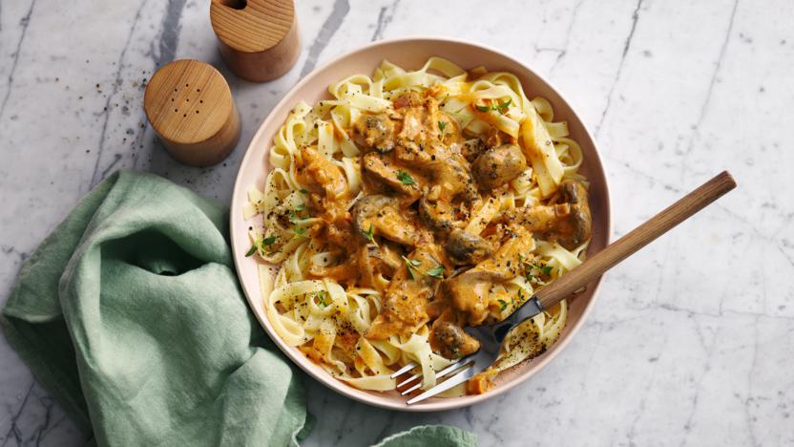
DID YOU KNOW?
“Cashews are an amazing source of copper which is great for bone health! So, you should be going nuts for cashews! “

Nutrition – Total / Per Serving
Calories: 800kcal / 400kcal
Carbohydrates: 300g / 150g
Protein: 80g / 40g
Fat: 60g / 30g
Fibre: 4g / 2g
Sugar: 3g / 1.5g
Ingredients
150g of basmati rice
150g of closed cup mushrooms
2 portobello mushrooms
2 tbsp of peanut butter
2 tbsp of massaman curry paste
250ml of coconut milk
30g of cashew nuts
1 lime
2 garlic gloves
150ml vegetable stock






Good for:

Star Rating:




Method


Step 1 - Preparation
Boil the kettle.
Thinly slice the closed cup mushrooms and garlic.
Slice the Portobello mushrooms into chunks.
Prepare the vegetable stock according to the packet instructions.
Half the lime.

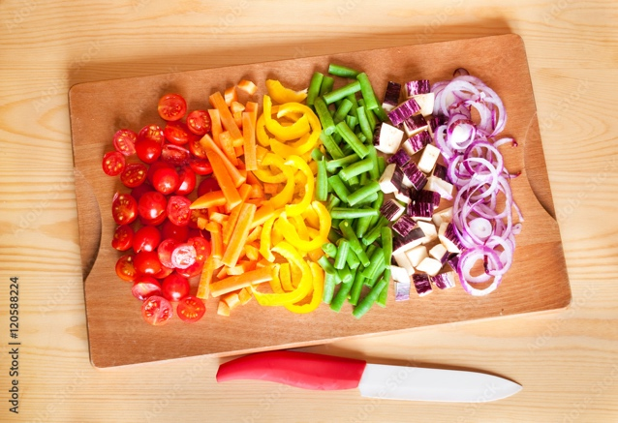

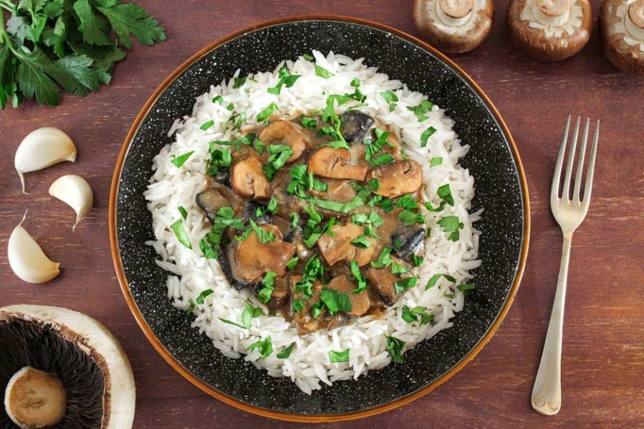
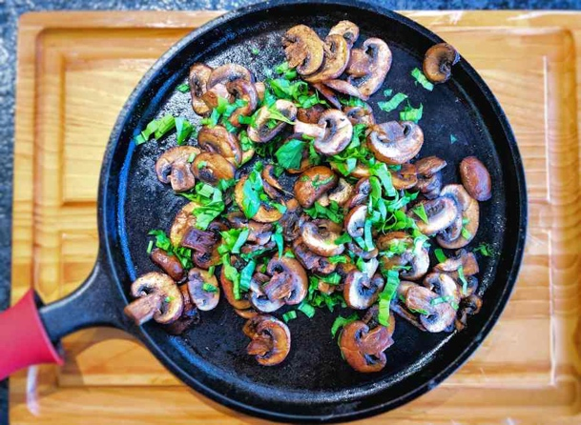
Step 4 – Bring it Together
Remove the frying pan from the heat and squeeze in the juice from half a lime.
Squeeze in the other half of the lime to the rice and mix well.
Spoon your rice into your bowls.
Add the curry to the bowls and sprinkle over the cashews.

Enjoy!
Step 3 – Frying
Put your frying pan back on the heat and add a drizzle of oil.
Add the mushrooms until golden brown (~3-4 mins).
Add the garlic to the frying pan and stir.
Add the massaman curry paste to the frying pan and stir.
Stir for 1 minute.
Pour in the coconut milk and vegetable stock.
Add the peanut butter and stir well.
Mix and let simmer over low heat until the sauce has reduced by half. (~7-9 minutes)
Step 2 – Rice & Cashews
Cook the rice according to the package instructions.
Heat up a frying pan and add the cashews. (1-2 minutes)
Transfer the cashews to a bowl and put to the side for later.

